WEEK 5 TASK
Deep Learning Application in Data Science
Handwritten Digit Classification using a PyTorch Neural Network
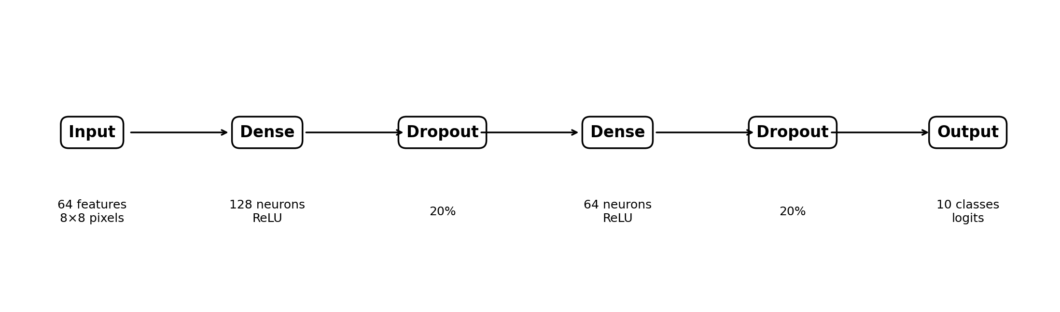
Public dataset: scikit-learn Digits Dataset • Framework: PyTorch • Task: Multiclass Classification

Dataset: sklearn.datasets.load_digits
Total samples: 1,797
Input representation: 64 standardized pixel features (8 × 8 grayscale image)
Classes: 10 digits: 0–9
Test set: 360 samples (20% stratified split)
Final test accuracy: 98.61%

Contents
- 1. Executive Summary
- 2. Problem Statement and Objective
- 3. Dataset Description and Data Understanding
- 4. Data Preprocessing
- 5. Exploratory Analysis and Data Examples
- 6. Neural Network Architecture
- 7. Design Decisions and Hyperparameters
- 8. Training Process
- 9. Evaluation Metrics and Results
- 10. Error Analysis and Critical Discussion
- 11. Challenges Encountered and Solutions
- 12. Concrete Improvements and Future Experiments
- 13. Reproducibility and How to Run
- 14. Conclusion
- Appendix A. Complete Python Code

1. Executive Summary
This project applies a feed-forward deep neural network to handwritten digit classification. The objective is to demonstrate the complete deep-learning workflow: selecting a public dataset, preprocessing numerical features, designing a neural network, training with validation monitoring, evaluating with multiple metrics, analyzing errors, and proposing concrete improvements.
The dataset contains 1,797 grayscale digit images represented by 64 pixel features. After a stratified 80/20 split, the model was evaluated on 360 previously unseen test samples. The final model achieved 98.61% test accuracy, 98.66% weighted precision, 98.61% weighted recall, and 98.61% weighted F1-score. Only 5 of the 360 test images were misclassified.
As a reference point, a logistic-regression baseline achieved 97.22% accuracy. The neural network therefore improved accuracy by 1.39 percentage points on the same test split. This comparison makes the result more informative than reporting neural-network accuracy alone.

2. Problem Statement and Objective
Problem: Given a small grayscale image of a handwritten digit, predict which digit (0–9) it represents.
Machine-learning formulation: this is a supervised multiclass classification problem with 10 mutually exclusive target classes. Each input is an 8 × 8 image, flattened into 64 numerical pixel-intensity features.

Project objectives
- Build a neural network using a mainstream deep-learning framework (PyTorch).
- Use a reproducible train/validation/test workflow.
- Justify the architecture, activation functions, optimizer, learning rate, batch size, dropout, and regularization.
- Evaluate the model using accuracy, precision, recall, F1-score, and a confusion matrix.
- Identify concrete failure cases rather than discussing errors only in general terms.
- Discuss limitations and propose measurable, technically specific improvements.

3. Dataset Description and Data Understanding
The project uses the public scikit-learn Digits dataset. It contains 1,797 labeled examples of handwritten digits from 0 through 9. Each example is an 8 × 8 grayscale image, so the raw image can be represented by 64 pixel values. The target variable has 10 classes.
Property | Value
Number of samples | 1,797
Input size | 64 features
Original image shape | 8 × 8 pixels
Number of classes | 10
Classes | 0, 1, 2, 3, 4, 5, 6, 7, 8, 9
Training split | 1,437 samples
Test split | 360 samples
Validation split | 216 samples, taken from the training portion
Random seed | 42

Why this dataset is suitable
It is small enough to train quickly on CPU while still representing a real image-classification problem. It also makes the full workflow easy to reproduce because the dataset is bundled with scikit-learn and does not require a separate download.

Class balance
The class counts in the complete dataset are: 0: 178, 1: 182, 2: 177, 3: 183, 4: 181, 5: 182, 6: 181, 7: 179, 8: 174, 9: 180. The stratified split preserves approximately the same class proportions in the training and test sets.
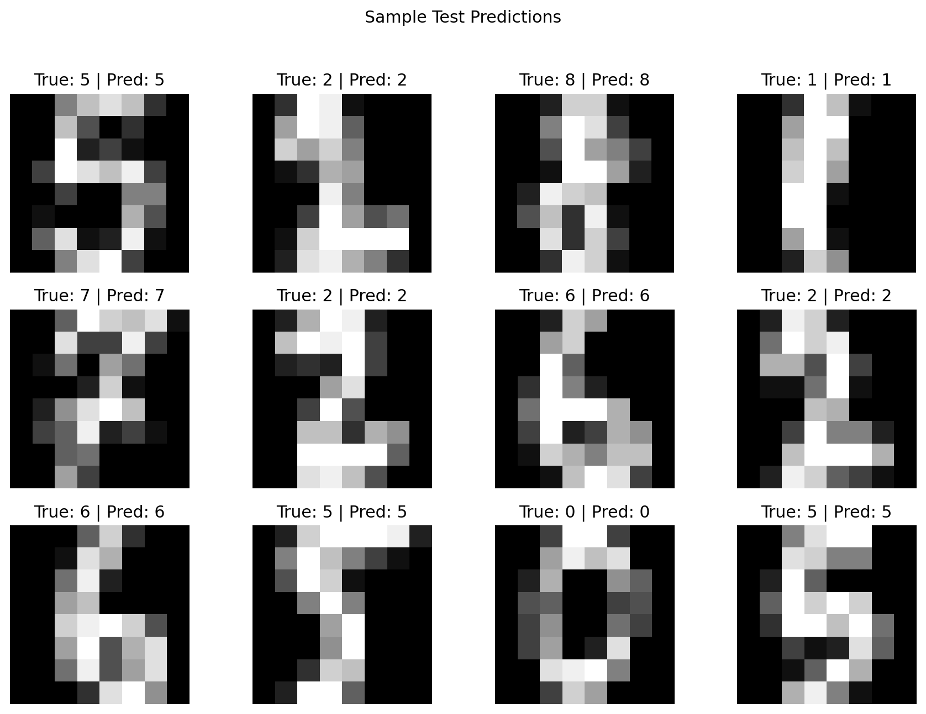
Figure 1. Example test images and predictions.

4. Data Preprocessing
Step 1 — Stratified split: 80% of the data was used for training and 20% for final testing. Stratification keeps the 10 digit classes represented proportionally.
Step 2 — Validation set: 15% of the training portion was separated as validation data. This gives 1,221 optimization samples and 216 validation samples.
Step 3 — Standardization: StandardScaler was fitted only on the training data and then applied to validation and test data. This prevents information from the test set leaking into training.
Step 4 — Tensor conversion: The NumPy arrays were converted to PyTorch tensors and loaded with mini-batches of 32.

Why standardization matters
The neural network uses gradient-based optimization. Standardizing features so that their scales are comparable usually makes optimization more stable. A key implementation detail is that the scaler is fitted on training data only; fitting it on all 1,797 samples would allow test-set information to influence preprocessing.

5. Exploratory Analysis and Data Examples
The original images are tiny 8 × 8 representations. This is important when interpreting the results: the model is not seeing high-resolution handwriting with realistic variations such as paper texture, camera angle, shadows, or large changes in stroke width.
A concrete example is class 8. In the final test set, 32 of 35 class-8 samples were correctly classified, while 3 were predicted as other digits. This makes class 8 the most visible source of errors in this particular run.
Another concrete example is class 1: 35 of 36 samples were correctly classified and 1 was predicted as class 4. The confusion matrix is more informative than accuracy alone because it shows exactly where the mistakes occurred.

6. Neural Network Architecture
Figure 2. Implemented neural-network architecture.
Layer | Output | Purpose | Parameters
Input | 64 | Receives flattened 8×8 pixels | 0
Linear + ReLU | 128 | Learns nonlinear feature combinations | 8,320
Dropout | 128 | Regularization at 20% | 0
Linear + ReLU | 64 | Compresses learned representation | 8,256
Dropout | 64 | Regularization at 20% | 0
Linear | 10 | Produces one logit per digit class | 650
Total trainable parameters: 17,226. The model is intentionally compact because the input dataset is small. A much larger network would increase computational cost and could memorize the training set without providing a meaningful generalization benefit.

7. Design Decisions and Hyperparameters
Choice | Value | Reason
Hidden layers | 2 | Enough capacity for nonlinear interactions while keeping the model compact.
Hidden units | 128 → 64 | Starts with a wider representation and gradually compresses it.
Activation | ReLU | Simple, fast, and suitable for hidden layers.
Output activation | None / logits | CrossEntropyLoss internally handles the class probabilities.
Loss | CrossEntropyLoss | Standard choice for single-label multiclass classification.
Optimizer | Adam | Adaptive learning rates; good default for small neural networks.
Learning rate | 0.001 | Common starting point that worked well in this experiment.
Batch size | 32 | Balances gradient stability and computation.
Dropout | 0.20 | Adds regularization to reduce overfitting risk.
Weight decay | 0.0001 | Adds L2-style regularization.
Maximum epochs | 50 | Provides enough training opportunity without excessive runtime.
Early stopping | Patience 7 | Stops if validation loss stops improving.

Parameter-count example
The first dense layer has (64 × 128) + 128 = 8,320 trainable parameters. The second has (128 × 64) + 64 = 8,256, and the output layer has (64 × 10) + 10 = 650. Therefore, 8,320 + 8,256 + 650 = 17,226 trainable parameters.

8. Training Process
The model was trained for up to 50 epochs using mini-batches of 32. In this run, all 50 epochs were completed. The best validation-loss checkpoint occurred at epoch 50. Training took approximately 3.03 seconds in the experiment environment.
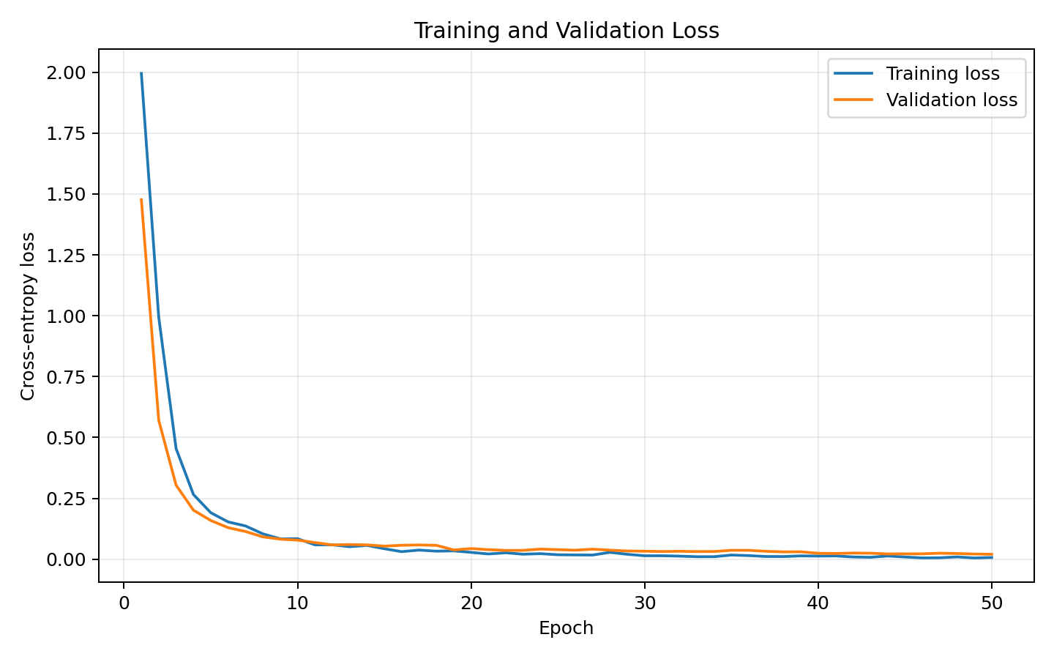
Figure 3. Training and validation loss.
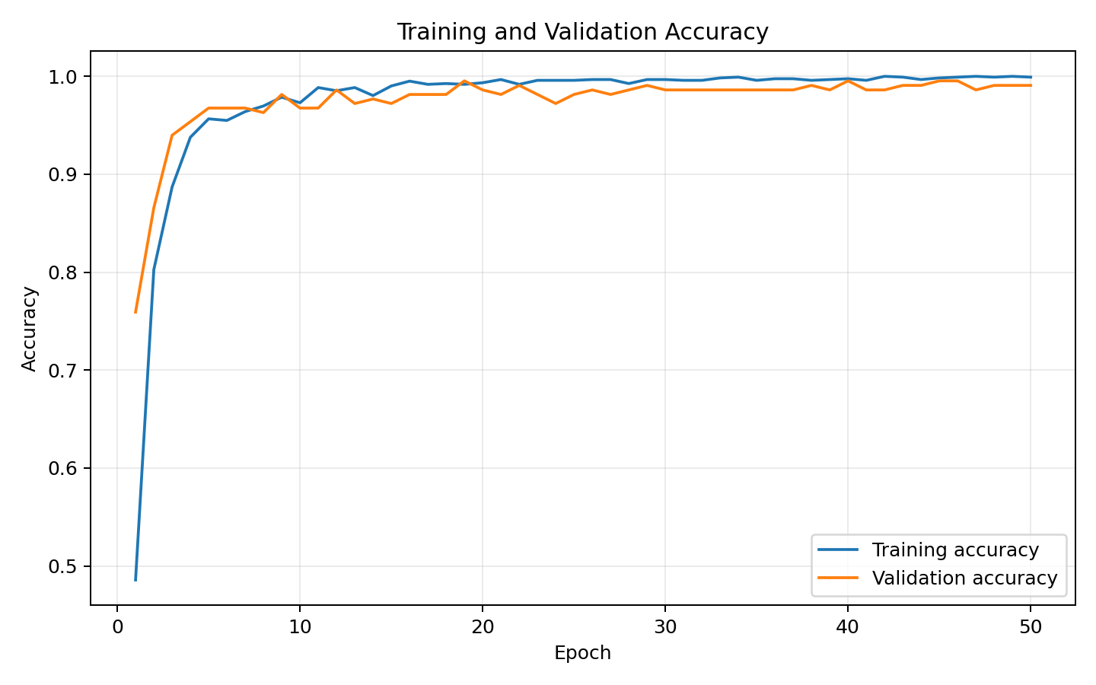
Figure 4. Training and validation accuracy.
The purpose of tracking validation metrics is to detect a situation where training performance keeps improving while validation performance stops improving. Dropout, weight decay, and validation monitoring provide three different mechanisms for controlling this risk.

9. Evaluation Metrics and Results
Metric | Result | Interpretation
Accuracy | 98.61% | 355 of 360 test samples correct.
Weighted precision | 98.66% | Balances precision according to class support.
Weighted recall | 98.61% | Measures how many true samples were recovered.
Weighted F1 | 98.61% | Harmonic mean of precision and recall.
Macro F1 | 98.60% | Gives every digit class equal importance.
Baseline accuracy | 97.22% | Logistic regression on the same standardized split.
Improvement | 1.39 pp | Absolute accuracy gain over the baseline.
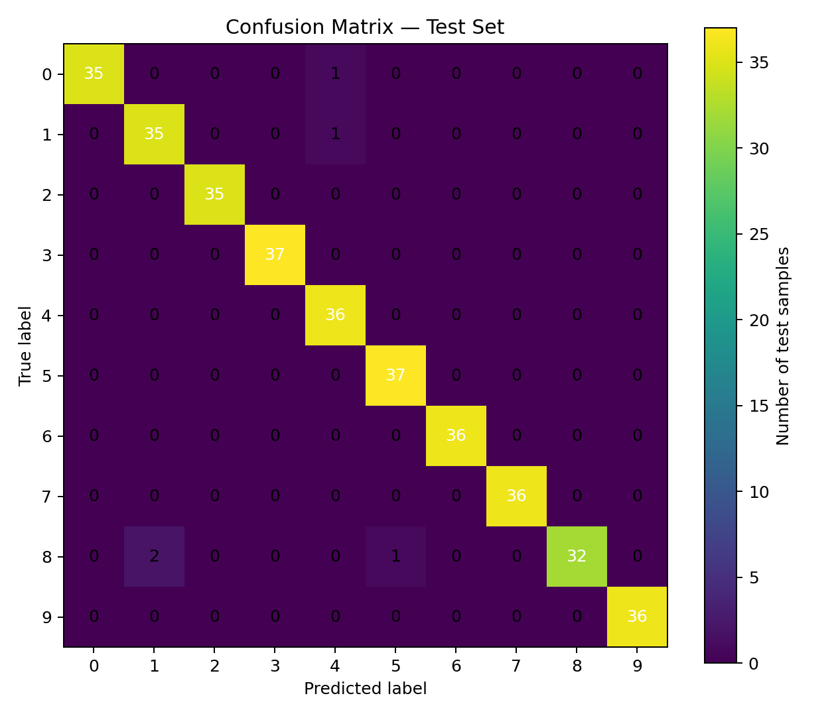
Figure 5. Confusion matrix for the 360-sample test set.

Class-level analysis
Digit | Support | Precision | Recall | F1
0 | 36 | 1.000 | 0.972 | 0.986
1 | 36 | 0.946 | 0.972 | 0.959
2 | 35 | 1.000 | 1.000 | 1.000
3 | 37 | 1.000 | 1.000 | 1.000
4 | 36 | 0.947 | 1.000 | 0.973
5 | 37 | 0.974 | 1.000 | 0.987
6 | 36 | 1.000 | 1.000 | 1.000
7 | 36 | 1.000 | 1.000 | 1.000
8 | 35 | 1.000 | 0.914 | 0.955
9 | 36 | 1.000 | 1.000 | 1.000
The weakest recall in this run was for digit 8: 32 of 35 class-8 samples were correctly identified, giving 91.43% recall. The three errors were predicted as 1 (twice) and 5 (once). This is a concrete example of why class-level metrics and error analysis matter even when overall accuracy is high.

10. Error Analysis and Critical Discussion
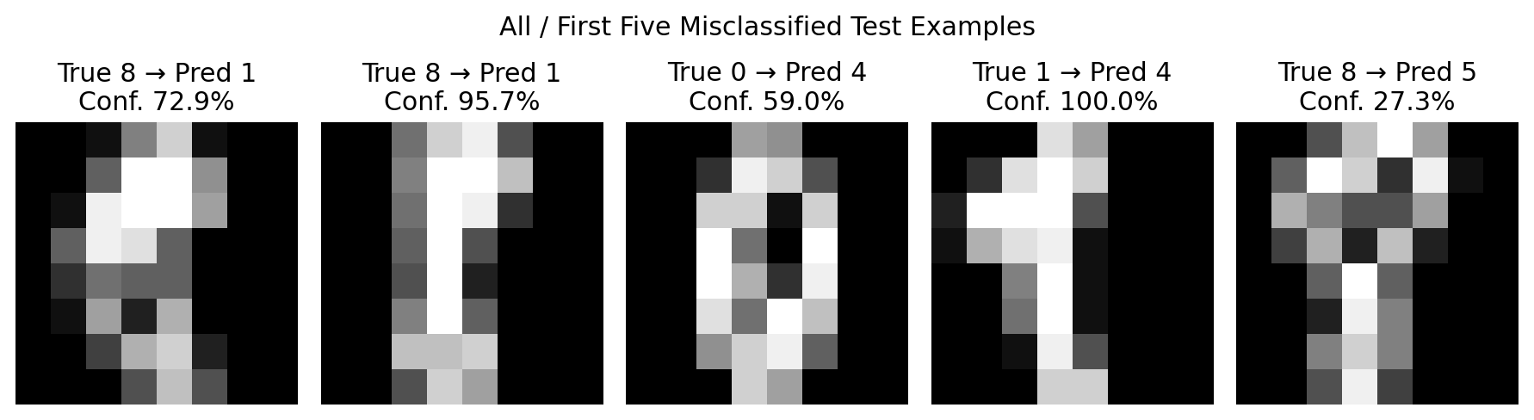
Figure 6. Misclassified test examples from the experiment.
The model made 5 errors out of 360 test samples. The observed errors were: true 8 → predicted 1 (72.9% confidence); true 8 → predicted 1 (95.7% confidence); true 0 → predicted 4 (59.0% confidence); true 1 → predicted 4 (100.0% confidence); true 8 → predicted 5 (27.3% confidence).
A notable point is that high confidence does not guarantee correctness. For example, one true-1 image was classified as 4 with approximately 100% model confidence. This suggests that the network learned a feature pattern that strongly resembled the training examples of class 4, even though the human-readable label was 1.
The test set is also relatively small. A difference of one correct prediction changes accuracy by about 0.28 percentage points. Therefore, the reported 98.61% should not be interpreted as a universal performance guarantee for handwritten digits outside this dataset.

11. Challenges Encountered and Solutions
Challenge | Evidence / risk | Action taken
Small dataset | Only 1,797 total samples; deep models can overfit small datasets. | Used a compact 17,226-parameter MLP plus dropout and weight decay.
Overfitting risk | Training accuracy can rise faster than validation accuracy. | Tracked validation loss/accuracy and kept dropout + early-stopping logic.
Data leakage risk | Scaling the full dataset before splitting would expose test statistics. | Fit StandardScaler only on the training portion.
Metric blindness | 98%+ accuracy can hide class-specific failures. | Reported precision, recall, F1, confusion matrix, and individual error examples.
Resource constraints | A large CNN is unnecessary for an 8×8 dataset. | Used a lightweight MLP; the observed run completed in about 3 seconds in the experiment environment.

12. Concrete Improvements and Future Experiments
The next iteration should not simply say 'use a better model'. Each improvement should be testable with a defined change and a measurable evaluation criterion.
Improvement | Concrete implementation | What to measure | Expected benefit
CNN instead of MLP | Reshape each 64-feature vector back to 1×8×8 and test Conv2D-style layers using PyTorch Conv2d. | Test accuracy, macro-F1, parameter count, training time. | Convolution can exploit local stroke patterns and spatial structure that a flat MLP does not explicitly encode.
Hyperparameter search | Try learning rates 0.0003, 0.001, 0.003; hidden widths 64/128/256; dropout 0.0/0.2/0.4. | Validation F1 and validation loss for each configuration. | Identifies whether the current 0.001/128-64/0.2 setting is close to optimal.
Data augmentation | Create small rotations, translations, or additive pixel noise during training. | Compare augmented vs. non-augmented test accuracy and class-8 recall. | May improve robustness to writing variations.
Cross-validation | Use 5-fold stratified cross-validation for model selection. | Mean and standard deviation of accuracy/F1 across 5 folds. | Reduces dependence on one random 80/20 split.
Calibration / confidence analysis | Measure confidence distributions and optionally apply temperature scaling. | Reliability curve and expected calibration error. | Useful when predictions are used in a downstream decision system.
Explainability | Inspect influential pixels with permutation or gradient-based methods. | Qualitative comparison of important regions for correct and incorrect predictions. | Helps determine whether the model is using sensible stroke regions.

Example of a concrete improvement experiment
Instead of writing 'increase the model size', a stronger experiment would be: train three variants with hidden sizes 64→32, 128→64, and 256→128 using the same random seed, batch size, optimizer, learning rate, and number of epochs. Record validation macro-F1, test accuracy, parameter count, and training time. This isolates architecture capacity as the variable being tested.

13. Reproducibility and How to Run
The accompanying Python file is named week5_deep_learning_digits.py. It contains the complete workflow, including data loading, preprocessing, model definition, training, evaluation, baseline comparison, and plot generation.
Suggested environment:
- Python 3.10+ (Python 3.13 was used for this report generation environment).
- PyTorch
- NumPy
- scikit-learn
- Matplotlib
Run the project with:
python week5_deep_learning_digits.py
The script creates a week5_outputs folder containing training-loss, training-accuracy, and confusion-matrix plots. Because load_digits() is included with scikit-learn, the project does not depend on a separate dataset download.

14. Conclusion
This project demonstrates an end-to-end deep-learning classification workflow on a public dataset. The final MLP achieved 98.61% accuracy and 98.61% weighted F1 on 360 unseen test samples, while a logistic-regression baseline achieved 97.22%. The neural network therefore showed a 1.39-percentage-point improvement under the same split.
The most important practical lesson is that model accuracy alone is not enough. The confusion matrix revealed specific weaknesses, especially for digit 8, and the confidence analysis showed that a highly confident prediction can still be wrong. Future work should therefore combine model changes with controlled experiments and measurable evaluation criteria rather than relying on vague statements such as 'use more layers' or 'tune the model'.

Appendix A. Complete Python Code
The following is the same code supplied as the separate .py file. It is included here so the report is self-contained.
"""
Week 5 Deep Learning Application in Data Science
Project: Handwritten Digit Classification using a PyTorch Neural Network

Dataset:
sklearn.datasets.load_digits
1,797 samples, 64 input features (8x8 grayscale pixels), 10 classes.

Run:
python week5_deep_learning_digits.py

Requirements:
numpy, pandas, scikit-learn, matplotlib, torch
"""

from pathlib import Path
import time
import numpy as np
import matplotlib.pyplot as plt
import torch
import torch.nn as nn
from torch.utils.data import DataLoader, TensorDataset
from sklearn.datasets import load_digits
from sklearn.model_selection import train_test_split
from sklearn.preprocessing import StandardScaler
from sklearn.linear_model import LogisticRegression
from sklearn.metrics import (
accuracy_score,
precision_recall_fscore_support,
confusion_matrix,
classification_report,
)

SEED = 42
np.random.seed(SEED)
torch.manual_seed(SEED)

OUTPUT_DIR = Path("week5_outputs")
OUTPUT_DIR.mkdir(exist_ok=True)

class DigitMLP(nn.Module):
"""Fully connected neural network for 10-class digit classification."""

def __init__(self):
super().__init__()
self.network = nn.Sequential(
nn.Linear(64, 128),
nn.ReLU(),
nn.Dropout(0.20),
nn.Linear(128, 64),
nn.ReLU(),
nn.Dropout(0.20),
nn.Linear(64, 10),
)

def forward(self, x):
return self.network(x)

def main():
# 1. Load public dataset
digits = load_digits()
X = digits.data.astype(np.float32)
y = digits.target.astype(np.int64)

print(f"Total samples: {len(X)}")
print(f"Features per sample: {X.shape[1]}")
print(f"Classes: {len(np.unique(y))}")

# 2. Stratified 80/20 train-test split
X_train_raw, X_test_raw, y_train, y_test = train_test_split(
X,
y,
test_size=0.20,
stratify=y,
random_state=SEED,
)

# 3. Standardize using training data only
scaler = StandardScaler()
X_train = scaler.fit_transform(X_train_raw).astype(np.float32)
X_test = scaler.transform(X_test_raw).astype(np.float32)

# 4. Create validation split from training set
X_tr, X_val, y_tr, y_val = train_test_split(
X_train,
y_train,
test_size=0.15,
stratify=y_train,
random_state=SEED,
)

train_loader = DataLoader(
TensorDataset(torch.tensor(X_tr), torch.tensor(y_tr)),
batch_size=32,
shuffle=True,
)

val_x = torch.tensor(X_val)
val_y = torch.tensor(y_val)
test_x = torch.tensor(X_test)

# 5. Define model, loss and optimizer
model = DigitMLP()
criterion = nn.CrossEntropyLoss()
optimizer = torch.optim.Adam(
model.parameters(),
lr=1e-3,
weight_decay=1e-4,
)

# 6. Train with validation monitoring
history = []
best_val_loss = float("inf")
best_state = None
patience = 7
wait = 0
max_epochs = 50

start_time = time.time()

for epoch in range(1, max_epochs + 1):
model.train()
running_loss = 0.0
correct = 0
total = 0

for xb, yb in train_loader:
optimizer.zero_grad()

logits = model(xb)
loss = criterion(logits, yb)

loss.backward()
optimizer.step()

running_loss += loss.item() * len(yb)
total += len(yb)
correct += (logits.argmax(dim=1) == yb).sum().item()

train_loss = running_loss / total
train_acc = correct / total

model.eval()
with torch.no_grad():
val_logits = model(val_x)
val_loss = criterion(val_logits, val_y).item()
val_acc = (
(val_logits.argmax(dim=1) == val_y)
.float()
.mean()
.item()
)

history.append(
(epoch, train_loss, train_acc, val_loss, val_acc)
)

print(
f"Epoch {epoch:02d} | "
f"train_loss={train_loss:.4f} | "
f"train_acc={train_acc:.4f} | "
f"val_loss={val_loss:.4f} | "
f"val_acc={val_acc:.4f}"
)

if val_loss < best_val_loss - 1e-5:
best_val_loss = val_loss
best_state = {
key: value.detach().clone()
for key, value in model.state_dict().items()
}
wait = 0
else:
wait += 1
if wait >= patience:
print("Early stopping triggered.")
break

training_seconds = time.time() - start_time
model.load_state_dict(best_state)

# 7. Test evaluation
model.eval()
with torch.no_grad():
logits = model(test_x)
probabilities = torch.softmax(logits, dim=1).numpy()
y_pred = logits.argmax(dim=1).numpy()

accuracy = accuracy_score(y_test, y_pred)
precision, recall, f1, _ = precision_recall_fscore_support(
y_test,
y_pred,
average="weighted",
zero_division=0,
)

print("\n===== TEST RESULTS =====")
print(f"Training time: {training_seconds:.2f} seconds")
print(f"Accuracy: {accuracy:.4f}")
print(f"Precision: {precision:.4f}")
print(f"Recall: {recall:.4f}")
print(f"F1-score: {f1:.4f}")
print("\nClassification report:")
print(classification_report(y_test, y_pred, digits=4))

# 8. Baseline comparison
baseline = LogisticRegression(max_iter=2000, random_state=SEED)
baseline.fit(X_train, y_train)
baseline_pred = baseline.predict(X_test)
baseline_acc = accuracy_score(y_test, baseline_pred)

print(f"Logistic-regression baseline accuracy: {baseline_acc:.4f}")
print(
"Neural-network improvement over baseline: "
f"{(accuracy - baseline_acc) * 100:.2f} percentage points"
)

# 9. Confusion matrix
cm = confusion_matrix(y_test, y_pred)
print("\nConfusion matrix:")
print(cm)

# 10. Save plots
epochs = [h[0] for h in history]

plt.figure(figsize=(8, 5))
plt.plot(epochs, [h[1] for h in history], label="Training loss")
plt.plot(epochs, [h[3] for h in history], label="Validation loss")
plt.xlabel("Epoch")
plt.ylabel("Cross-entropy loss")
plt.title("Training and Validation Loss")
plt.legend()
plt.grid(alpha=0.25)
plt.tight_layout()
plt.savefig(OUTPUT_DIR / "training_loss.png", dpi=180)
plt.close()

plt.figure(figsize=(8, 5))
plt.plot(epochs, [h[2] for h in history], label="Training accuracy")
plt.plot(epochs, [h[4] for h in history], label="Validation accuracy")
plt.xlabel("Epoch")
plt.ylabel("Accuracy")
plt.title("Training and Validation Accuracy")
plt.legend()
plt.grid(alpha=0.25)
plt.tight_layout()
plt.savefig(OUTPUT_DIR / "training_accuracy.png", dpi=180)
plt.close()

plt.figure(figsize=(7, 6))
plt.imshow(cm)
plt.title("Confusion Matrix")
plt.xlabel("Predicted label")
plt.ylabel("True label")
plt.xticks(range(10))
plt.yticks(range(10))
threshold = cm.max() / 2
for i in range(10):
for j in range(10):
plt.text(
j, i, int(cm[i, j]),
ha="center",
va="center",
color="white" if cm[i, j] > threshold else "black",
)
plt.colorbar(label="Number of samples")
plt.tight_layout()
plt.savefig(OUTPUT_DIR / "confusion_matrix.png", dpi=180)
plt.close()

# 11. Show misclassification examples in the console
misclassified = np.where(y_pred != y_test)[0]
print(f"\nMisclassified test samples: {len(misclassified)}")
for idx in misclassified:
confidence = probabilities[idx].max() * 100
print(
f"Index {idx}: true={y_test[idx]}, "
f"predicted={y_pred[idx]}, confidence={confidence:.2f}%"
)

if __name__ == "__main__":
main()

